Cub Scout Sticker Templates

It’s no secret that children love stickers. With the Cub Scout sticker templates included in this kit, you can create fun “Join Cub Scouting” stickers with the date, location, and time of Cub Scout recruitment information.

Use Avery label stock 5261 or 5263, or create your own templates using the stock of your choice.

Instructions
- Visit www.cccbsa.org and click on the School Night Resources link.
- Locate the link for “Stickers” and click.
- Select and open the sticker template you want.
- Customize the template with the time, date, and location of the event, adding any additional information required.
- Print the labels on a printer using the correct label stock following manufacturer’s instructions.

Important: Some children may not want to have stickers applied to them. Ask your volunteers not to place recruiting stickers on the children. Distribute stickers with the paper backing so the children may choose whether or not to apply them.

I’m Joining Cub Scouts!

Date __________________________

Time _________________________

Location _____________________

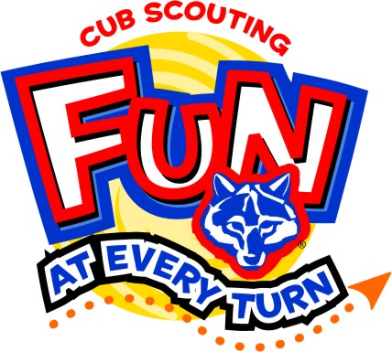
www.BeAScout.org

I’m Joining Cub Scouts!

Date _______________________________
Time _______________________________
Location ___________________________

I’m Joining Cub Scouts!  Date _______________________________  Time _______________________________  Location ___________________________ |  | I’m Joining Cub Scouts!  Date _______________________________  Time _______________________________  Location ___________________________
I’m Joining Cub Scouts!  Date _______________________________  Time _______________________________  Location ___________________________ |  | I’m Joining Cub Scouts!  Date _______________________________  Time _______________________________  Location ___________________________
I’m Joining Cub Scouts!  Date _______________________________  Time _______________________________  Location ___________________________ |  | I’m Joining Cub Scouts!  Date _______________________________  Time _______________________________  Location ___________________________
I’m Joining Cub Scouts!  Date _______________________________  Time _______________________________  Location ___________________________ |  | I’m Joining Cub Scouts!  Date _______________________________  Time _______________________________  Location ___________________________
I’m Joining Cub Scouts!  Date _______________________________  Time _______________________________  Location ___________________________ |  | I’m Joining Cub Scouts!  Date _______________________________  Time _______________________________  Location ___________________________
I’m Joining Cub Scouts!  Date _______________________________  Time _______________________________  Location ___________________________ |  | I’m Joining Cub Scouts!  Date _______________________________  Time _______________________________  Location ___________________________
I’m Joining Cub Scouts!  Date _______________________________  Time _______________________________  Location ___________________________ |  | I’m Joining Cub Scouts!  Date _______________________________  Time _______________________________  Location ___________________________
I’m Joining Cub Scouts!  Date _______________________________  Time _______________________________  Location ___________________________ |  | I’m Joining Cub Scouts!  Date _______________________________  Time _______________________________  Location ___________________________
I’m Joining Cub Scouts!  Date _______________________________  Time _______________________________  Location ___________________________ |  | I’m Joining Cub Scouts!  Date _______________________________  Time _______________________________  Location ___________________________
I’m Joining Cub Scouts!  Date _______________________________  Time _______________________________  Location ___________________________ |  | I’m Joining Cub Scouts!  Date _______________________________  Time _______________________________  Location ___________________________

I’m Joining Cub Scouts!  Date __________________________  Time _________________________  Location _____________________  www.BeAScout.org |  | I’m Joining Cub Scouts!  Date __________________________  Time _________________________  Location _____________________  www.BeAScout.org
I’m Joining Cub Scouts!  Date __________________________  Time _________________________  Location _____________________  www.BeAScout.org |  | I’m Joining Cub Scouts!  Date __________________________  Time _________________________  Location _____________________  www.BeAScout.org
I’m Joining Cub Scouts!  Date __________________________  Time _________________________  Location _____________________  www.BeAScout.org |  | I’m Joining Cub Scouts!  Date __________________________  Time _________________________  Location _____________________  www.BeAScout.org
I’m Joining Cub Scouts!  Date __________________________  Time _________________________  Location _____________________  www.BeAScout.org |  | I’m Joining Cub Scouts!  Date __________________________  Time _________________________  Location _____________________  www.BeAScout.org
I’m Joining Cub Scouts!  Date __________________________  Time _________________________  Location _____________________  www.BeAScout.org |  | I’m Joining Cub Scouts!  Date __________________________  Time _________________________  Location _____________________  www.BeAScout.org

